**ROCK MARINE SERVICES WEBSITE**

**HOME PAGE 2**

**ABOUT US**

**SERVICES 2**

**PROJECT 2**

**CONTACT US**

**SERVICES:**

**SHIP REPAIR**

1. Drydocking: This process involves hauling the ship out of the water for repairs and maintenance to the hull, propellers, and other underwater components.
2. Steel repairs: This includes welding and cutting of steel to repair or replace damaged sections of the hull, decks, and bulkheads.
3. Machinery repairs: This includes repairs and maintenance to the ship's engines, generators, pumps, and other mechanical equipment.
4. Electrical repairs: This includes repairs and maintenance to the ship's electrical systems, including wiring, generators, and other electrical components.
5. Painting and blasting: This includes the removal of old paint and rust, surface preparation, and the application of new paint and coatings to protect the ship's steel from corrosion.
6. Outfitting: This includes the installation of new equipment and systems, such as navigation and communication systems, lifeboat and safety equipment, and other ship-specific systems.

**MAINTENANCE**

1. Routine inspections: This includes regular inspections of the ship's structure, machinery, and equipment to identify any issues that need to be addressed.
2. Preventive maintenance: This includes scheduled maintenance tasks such as oil changes, filter replacements, and other tasks that are performed on a regular basis to prevent equipment failure.
3. Repairs and replacements: This includes repairs and replacements of damaged or worn parts, such as engines, generators, pumps, and other mechanical and electrical equipment.
4. Cleaning and painting: This includes cleaning the ship's exterior and interior, as well as painting and coating the ship's steel to protect it from corrosion.
5. Safety equipment maintenance: This includes regular inspections, testing, and maintenance of the ship's safety equipment, such as lifeboats, fire extinguishers, and life jackets.
6. Documentation and record-keeping: This includes maintaining accurate records of all maintenance and repair work performed on the ship, as well as compliance with regulatory requirements.
7. Crew training: This includes training the crew on how to properly maintain and operate the ship's equipment, as well as safety procedures.

**Construction & FABRICATION**

1. Metal fabrication: This includes cutting, shaping, and welding of metal to create custom parts, components, and structures for a variety of applications.
2. Constnstrustion of tank a
3. Sheet metal fabrication: This involves the creation of parts and components from sheet metal using techniques such as cutting, punching, bending, and welding.
4. Welding: This includes various welding techniques such as TIG, MIG, stick, and flux-cored welding to join metal parts together.
5. CNC machining: This includes the use of computer-controlled machines to create custom parts and components with high precision and accuracy.
6. Assembly: This includes the process of putting together individual parts and components to create a finished product.
7. Custom fabrication: This includes the creation of unique and custom-designed parts, components, and equipment to meet specific customer needs.
8. Prototyping: This includes the creation of a prototype of a product or component that can be used for testing and evaluation before mass production.
9. Surface treatment: Surface treatment services such as sand blasting, polishing, anodizing and plating, to protect the surface of the metal and improve its aesthetic appearance.

**SUPPLY / LEASE**

1. Fuel and lubricants supply: This includes the provision of fuel and lubricants to ships and boats for their propulsion and machinery needs.
2. Provision supply: This includes the provision of food, water, and other supplies to ships and boats for their crew and passengers.
3. Spare parts supply: This includes the provision of spare parts and equipment to ships and boats for repairs and maintenance.
4. Technical support: This includes the provision of technical support and assistance to ships and boats, such as troubleshooting and repair services.
5. Mooring and berthing: This includes the provision of mooring and berthing services to ships and boats in ports and harbors.
6. Towing and salvage: This includes the provision of towing and salvage services to ships and boats in distress.
7. Vessel agency services: This includes the provision of agency services to ships and boats, such as customs clearance, immigration formalities, and other services required to enter and leave a port.
8. Safety equipment supply: This includes the provision of safety equipment such as life rafts, life jackets, fire extinguishers, and other safety equipment required to meet maritime regulations.

Top of Form

**DIVING / UNDERWATER INSPECTION**

Diving and underwater inspection services involve the use of trained divers to visually inspect underwater structures and equipment, such as ships, bridges, dams, and oil rigs. The divers use specialized equipment, including scuba gear and underwater cameras, to closely examine the condition of the structure or equipment and identify any potential issues.

The inspection process typically includes a thorough examination of the surface of the structure or equipment, as well as any internal areas that are accessible. The divers will also take measurements and gather data to help assess the condition of the structure or equipment.

Some common types of underwater inspection services include:

* Hull and propeller inspections: Divers inspect the exterior and interior of ships, looking for any damage or wear to the hull and propellers.
* Bridge inspections: Divers examine bridges for signs of wear, corrosion, or other damage, and check the condition of the supporting pilings.
* Dam inspections: Divers inspect dams for signs of erosion, cracking, or other structural issues.
* Oil rig inspections: Divers inspect offshore oil rigs for signs of corrosion or damage to the structure, and check the condition of the underwater pipelines.

Overall, the goal of diving and underwater inspection services is to identify any potential issues with the structure or equipment before they become major problems. By conducting regular inspections, organizations can ensure the safety and integrity of their underwater assets and minimize the risk of costly repairs or downtime.

**CIVIL CONSTRUSTION**

1. Site preparation: This includes clearing the land, removing debris and vegetation, and grading the site to prepare it for construction.
2. Excavation and grading: This includes digging trenches and foundations, and leveling the site to ensure proper drainage and a stable base for construction.
3. Utility installation and maintenance: This includes installing and maintaining water, sewer, gas, and electrical lines, as well as telecommunications and internet infrastructure.
4. Road and sidewalk construction: This includes building and maintaining roads, sidewalks, and other transportation infrastructure.
5. Concrete work: This includes pouring and finishing foundations, floors, and other concrete structures.
6. Demolition: This includes tearing down buildings or structures that are no longer needed or are in the way of new construction.
7. Erosion control: This includes measures to prevent soil erosion and protect the site from water damage.
8. Landscaping: This includes planting trees, grass, and other vegetation, as well as designing and building outdoor spaces.
9. Building maintenance and repair: This includes maintaining and repairing existing buildings and structures, such as roads, bridges, and other infrastructure.
10. Surveying and mapping: This includes measuring and mapping the land to ensure that construction is done according to plan and that the site is stable and safe.
11. Project management: This includes overseeing the entire construction project, including scheduling, budgeting, and coordinating with other contractors and workers.
12. Inspection and testing: This includes inspecting the site and materials to ensure that they comply with building codes and safety standards.

Top of Form

Bottom of Form

**LOGISTICS SERVICES**

1. Transportation: This includes arranging for the movement of goods by various modes of transportation, including truck, rail, air, and sea.
2. Warehousing and distribution: This includes storing and managing inventory, as well as distributing goods to customers or other locations.
3. Inventory management: This includes tracking and managing inventory levels, as well as forecasting future demand and adjusting production accordingly.
4. Packaging and assembly: This includes packaging products for shipment and assembly of products, as needed.
5. Supply chain management: This includes coordinating and optimizing the flow of goods, information, and resources throughout the entire supply chain.
6. Freight forwarding: This includes arranging for the transportation of goods, including arranging for ships, containers, and other equipment, as well as handling customs clearance and documentation.
7. Reverse logistics: This includes managing the return of goods and materials, such as processing returns, repairing or refurbishing products, and disposing of waste.
8. Transportation management: This includes managing the transportation of goods, including scheduling, tracking, and optimizing transportation routes and modes.
9. Customs brokerage: This includes handling the customs clearance process and documentation, including arranging for the payment of duties and taxes.
10. Logistics consulting: This includes providing expert advice and support on logistics and transportation issues.
11. Technology solutions: This includes software and technology solutions to manage and optimize logistics operations, such as transportation management systems, warehouse management systems, and supply chain visibility platforms.

Top of Form

**NDT**

* Rock Marine Services offers a wide range of Non-Destructive Testing (NDT) services to evaluate the properties of materials, components, and systems without causing damage. Our goal is to determine the integrity and reliability of structures and components and to identify any defects or anomalies that could compromise performance or safety. Our NDT services include various methods such as visual inspection, radiography, ultrasonics, magnetic particle inspection, liquid penetrant inspection, and eddy current testing. Each method has its own set of advantages and limitations. Our NDT services are commonly used in industries such as aerospace, oil and gas, construction, and manufacturing to ensure the safety and integrity of equipment and structures. Our certified and qualified personnel perform these services and the results of the testing are usually documented in a report that includes a detailed description of the method used, the results of the testing, and any defects or anomalies that were identified.
* Visual inspection: This is the simplest and most basic form of NDT, and involves looking at the surface of a material or component with the naked eye or with the aid of a magnifying glass, microscope, or borescope. Visual inspection is often used to detect surface defects such as cracks, corrosion, and surface finish issues.
* Radiography: This method uses X-rays or gamma rays to create an image of the internal structure of a material or component. Radiography can be used to detect internal defects such as cracks, voids, and inclusions that are not visible on the surface.
* Ultrasonics: This method uses high-frequency sound waves to create an image of the internal structure of a material or component. Ultrasonics can be used to detect internal defects such as cracks, voids, and inclusions that are not visible on the surface.
* Magnetic particle inspection: This method uses a magnetic field to detect surface or subsurface defects in ferromagnetic materials. Magnetic particle inspection is often used to detect cracks, laps, seams, and other surface discontinuities.
* Liquid Penetrant Inspection (LPI): This method uses a liquid penetrant that is applied to the surface of a material or component and then removed. Any defects on the surface will allow the liquid to penetrate, and the excess liquid will be visible and indicate a defect.
* Eddy Current Testing (ECT): This method uses electromagnetic induction to detect surface and subsurface defects in non-ferromagnetic materials. Eddy current testing is often used to detect cracks, laps, seams, and other surface discontinuities.

**MACHINERY INSTALLATION**

Rockmarine Services specializes in machinery installation, providing expert physical installation and set-up of industrial machinery and equipment. Our services include assembling and connecting various components, running electrical and plumbing connections, programming and testing the equipment, and training operators on how to use it. Whether provided by the manufacturer or specialized installation companies, trust Rockmarine Services for all your machinery installation needs."

**INDUSTRIAL & MARINE ELECTRONIC CONTROL**

Rockmarine Services specializes in industrial and marine electronic control services. We provide expert design, installation, maintenance, and repair of electronic systems used in industrial and marine settings. Our services include control systems for manufacturing processes, automation systems for marine vessels, and electrical power systems for industrial and marine equipment. We offer programming and commissioning of control systems, troubleshooting and repair of electronic components, and regular maintenance to ensure optimal performance and longevity of the systems. With our specialized expertise in industrial and marine electronic control systems, Rockmarine Services is dedicated to providing the highest quality service to our clients.

**OFFSHORE STUCTURE AND PLATFORM**

**ABOUT US :**

Rock Marine Services Ltd. is engineering based and professionally driven. It is a fast growing Marine/Maritime, Offshore/Onshore service provider registered with the Department of Petroleum resources to operate within the Nigeria Oil and Gas sector, with permit No. N.8337/2013 and N. 8338/2013. And also, with a Civil Construction outfit serving the West African Sub-region.

**Mission**

To provide first class Rock Marine Services with world class standard, becoming a world class world wide world known oil and gas Marine Engineering, Jetties Construction and Marine Logistics Company originating from Nigeria.

**More Services**

* Marine logistics
* - Steel Fabrication Offshore/Onshore Facilities
* - Vessels/Ship Repairs
* - Construction/Tanks Inspection of pieplines
* - Onshore/Offshore Pipeline Fabrication & installation
* - Valves Maintenance
* - Quality Control Inspection/Calibratio

- Non Destructive Testing

• - Machinery Maintenance/Servicing and Over Hauls

• - Treatment and protection of Marine Facilities/Equipment

• - Refrigeration/Air conditioning Repairs/Electrical Repairs

• - Electronics Equipment

• - Facility Supply

• - Building of Large Houses/Estates

• - Jetty Construction/Management

• - Road Construction

• - Erosion Control

• - Dam Construction

• - Construction Equipment Lease

**Captions**

Bringing your vessel back to top condition"

"Trusted by ship owners and operators worldwide"

"A team of skilled professionals dedicated to keeping your ship running smoothly"

"Committed to safety, quality, and timely repairs"

"Experience the difference with [Company Name]"

"The go-to choice for comprehensive ship repair services"

"Innovative solutions for all your repair needs"

"Setting the standard for excellence in the industry"

"Partner with us for reliable and cost-effective repairs".

**Security Policy**

The Management of ROCK MARINE SERVICES LIMITED has committed itself to the establishment and maintenance of a quality management system aimed at providing assurance that the quality of products and services the company provides, is such that it meets with the objectives set out within the management system of ROCK MARINE SERVICES LIM ITED and the agreed requirements of the clients.

It is the policy of ROCK MARINE SERVICES LIMITED to provide products and services that meet the expectations of our client, the standards of ROCK MARINE SERVICES LIMITED and any regulatory or statutory requirements that may apply to the clients order.

To achieve these objectives, we will maintain a comprehensive program of quality management systems that are planned and developed in conjunction with other management functions to meet the latest requirements of ISO 9001:2000.

The implementation of the Quality Management System shall be a continuous process and once ROCK MARINE SERVICES LIMITED has attained the standards required, it will seek the necessary accreditation for ISO 9001:2000 through nationally approved agencies.

The policies, systems responsibilities and authorities as defined in the company's Quality Assurance Manual, shall be effective and binding on all ROCK MARINE SERVICES LIMITED employees, as these employees are responsible for producing quality products and or services.

ENGR. ELIJAH ESSIEN

CHAIRMAN

**EXCLUDE THE FOLLOWING**

**ABOUT US**

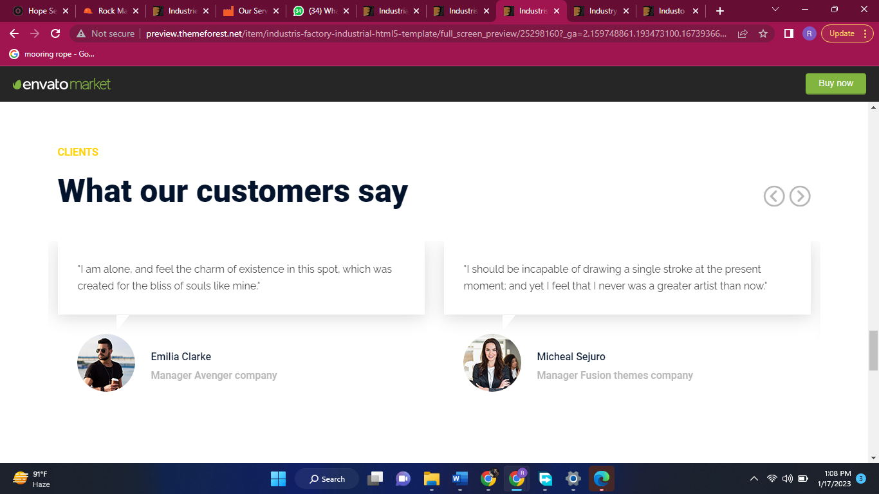

**HOME PAGE**

